Website Design report :

Used content :

CSS Syntax

CSS colors:

Colors are specified using predefined color names,

or RGB, HEX, HSL, RGBA, HSLA values.

CSS background:

The CSS background properties are used

to define the background effects for elements.

CSS Borders:

The CSS border properties allow

to specify the style, width, and

color of an element's border.

CSS Margin:

CSS Footer

CSS Padding

CSS Height/Width

CSS Box Model

CSS Text

CSS Font

CSS Icon

CSS Link

CSS Max-width

CSS Overflow

CSS Float

CSS Align

CSS Navigation Bar

CSS Dropdowns

CSS Image Gallery

CSS Website layout

CSS Rounded Corner

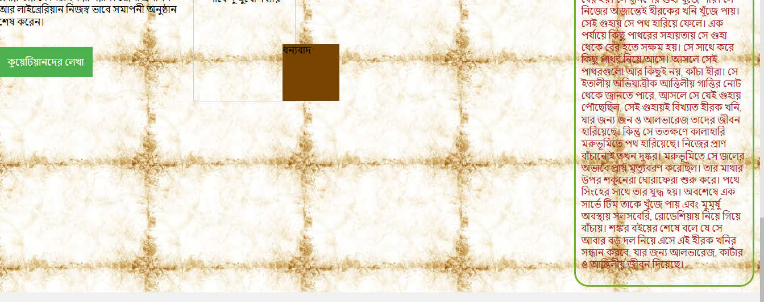CSS animations

Made by

Nishat Anjum Lea

Roll:1607009

Year:3rd ,Term:1st